Dated:_______

Declaration of Authorized Signatory

We,
- Prabhanjankuwar Upadhyay
- Kavita Upadhyay

Hereby solemnly affirm and declare that Prabhanjankuwar Upadhyay to act as an authorized Signatory for the business KWMCS Ventures LLP. For which applicable for signing the agreement with [Client Company].

All his actions in relation to his business will be binding on us.
Signatures of the persons who are whole time Director

Sr No. | Full Name | Signature
1 | Prabhanjankuwar Upadhyay | 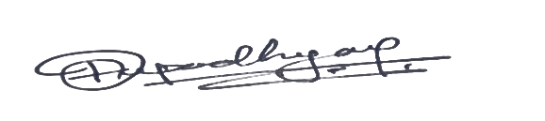
2 | Kavita Upadhyay | 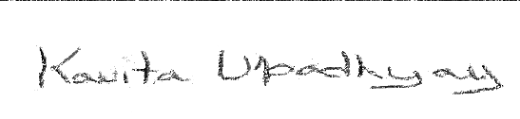

Acceptance as an authorized signatory

I Prabhanjankuwar Upadhyay here by solemnly accord my acceptance to act as an authorized signatory for the above referred business and all my acts shall be binding on the business


Prabhanjankuwar Upadhyay
(DIRECTOR)
Place:
Date-

